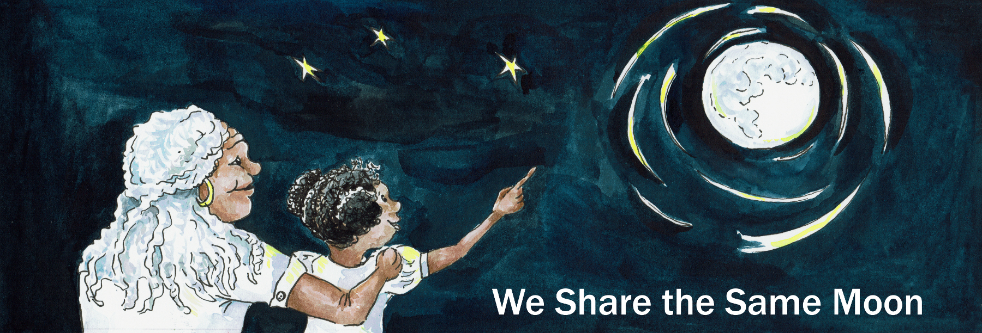
Suggested Age Range: 10 - 11 years; 11 - 12 years; 12 - 13 years; 13 - 14 years; Adult;
UK Curriculum: Key Stage Two; Key Stage Three;
Suggested UK Year Group: Year Six
UK Primary Curriculum Link: Light
Science Subject: Aurora
Science Question: What are the Aurora?
Suggested Science Activity: Aurora
Children with SEND: Use to boost comprehension of science vocabulary
EAL children: For confident older learners
Country of Origin: Sami - people of Sweden and Finland
Source: The Storytelling Star by James Riordan, contributed by Christer Willen

In the beginning, when the world began, the Sun and the Moon were the best of friends. But, once they both had children, their friendship began to falter.
As the two cots, one golden, one silver, stood side by side, Sun looked down and said:

"Oh, they look so perfect together! It is as if they were made for each other!
I think, that when they grow up, they should marry each other!”

Moon laughed, a little uneasily. “Oh, there is time enough to think of marriage when they are older. Let them decide for themselves.”

“No!” said Sun “All that would do is lead to arguments! What if one of them wanted to be married and the other did not? Let us avoid any arguments in the future and agree that they should marry now!”

“No!” said the Moon “My daughter shall decide for herself!”
“Neither you or I have the right to decide for her”

“Are you arguing with me?” said the Sun. “I say, they should be married!”
“If I have to argue for my daughter’s sake, I will!” said the Moon
“ I say, she will not be married until she is old enough to decide for herself”

Sun was outraged. How dare Moon argue with Sun!

“I am the Sun, I rule the sky” said Sun. “And I say - they will be married!”
“You have power only during the day!” said Moon

“ I rule the night. And I say they will not marry.”
“Hah!” said Sun. “Without my light - no-one could see you at night!”

And to prove her point, the sky was filled with a stormy light and huge clouds formed, which blocked the Moon from view. Which was exactly what Moon wanted!

Hidden behind the clouds, she wrapped her baby in a silver blanket and sent her down to Earth on a moon-beam, into the far, far North, when Sun rarely goes.

An old man was out in the snow, on his reindeer-driven sled. He was travelling towards a lake, to hunt for fish trapped and caught in the winter ice.

But as his sled slid across the snow and ice …

He heard something. A cry. A human sound. A baby’s cry.
Why was a baby out in the snow all alone?
The old man turned the sled towards the sound and the sled sped across the ice.
There was nothing ahead- save for one old tree.
And, as the sled slowed and slid past by the tree, the old man, heard the sound again from above. The baby was in the tree! The sled stopped. The old man climbed out.
And there, halfway up the tree, in a crook between two branches, was a small bundle.
So very small. The old man climbed slowly up the tree, and gently took hold of the baby. And two brown eyes looked at him and smiled up at him.
And he knew then, that he would guard this baby, with all his life.
He climbed down and wrapped the fragile bundle in furs and then turned the sled around and made for home.
As he grew within ear-shot of his house, the door opened and his wife stood there, astonished! “You are back so soon! You have caught enough fish already?”
“I have caught something more rare and precious than a fish!”
And he stooped and gathered up the baby and placed it in her arms.
And, as the old woman stroked the silver hair of the child, the baby smiled and looked up at her. And she knew then that she would love this baby - all her life.
The girl grew up within their village as their daughter. Every day, she would help her parents prepare and cook their food and then play with the other children, just like any other child.
But at night, whilst everyone was asleep, she would go outside and look up at the Moon, her mother, and weep. But, she knew that she was safe, down here on Earth.
For the Sun rarely reaches the Artic circle, and who would think of looking for a child up there in the frozen North, where so little lives? And so she was safe. For a while.

But, as she grew up, word spread of this beautiful young girl, with silver hair that fell to her waist. And so a young man, with hair so golden like the Sun, heard the rumour.
And followed the rumour until …

One day he found her, standing alone in the middle of the village.
And as soon as he looked at her, he knew she was the one for him! Just as his mother had promised!

And the Sun’s son strode up to her and caught her by the hand.
He opened his bag and took out the gift he had made for her. A pair of golden shoes.
And, as she looked at them, she knew, she just knew, without even trying them, that they would fit perfectly.

“Wear these shoes and be my bride!” He begged
What to do? What would you do?

“No” she said. “I won’t. Time enough for marriage when I am older. When I will choose and I will decide. Until then - I will not marry you!”

“But my mother promised you to me!”
“But my mother did not! And I will not be made to marry you!”

And she turned to face the sky. “Mother “she cried “Help me!”

But it was day-time and Moon’s power was weak.
Moon did the only thing she could.
She sent down a Moon-mist that covered the girl from view.
And then hidden within the mist - she ran!
She ran, away from her home, her people, all that she knew.
She did not stop to say goodbye or gather her belongings, she just ran.
Into the cold and ice.
And she ran through the day and she ran through the night.
Away from everyone and everything.
Until she came to a lake.It was dark but she could see the green and gold of the Northern Lights dancing overhead.
And in their light, she saw, a tumbledown house by the lake shore.
The door was open and she walked inside.
What a mess!

There were seven beds, with blankets strewn here and and there, and scraps of food left on the only table. The fire was out and the house was cold.
Without even thinking, she began to clear up the mess, tidy the room, make the beds, light the fire and put some porridge on the fire to cook.
And the empty house began to feel less forlorn. But still - where were the people ?
And the sky began to lighten.

And then she heard voices talking and laughing. Seven of them.
She grew frightened and hid herself within the mist once again. And watched.
Seven young men came into the house and stopped. They were amazed! Their house was clean! There was food on the table for breakfast!
The young men sat down at the table and starting eating. Soon they had eaten their fill. And without any more comment, they climbed wearily into their clean beds and fell instantly asleep.

The young woman came out of hiding, smiling, as began to tidy and clean around them once again. And when they woke up, they ate the food she had prepared and ran out the door. The young woman was curious. Who were they? She needed to sleep herself but instead she went to the door of the house and looked outside.
And stopped still with astonishment.
The laughing young men were striding into the sky!
Each of them had a sword and they began to mock-fight.
And as they fought, their swords struck against one another and sparks flew into the sky. And the sparks glowed green and gold.
And then the sparks began to grow and dance across the sky.
And as she watched the men too began to change.
They too glowed green and gold.
And so she realised that she was watching the Northern Lights changing from Human form to their Sky-form. And they were beautiful!
But one of them, it seemed to her, was more beautiful than the rest. The oldest one.

She went back inside and slept.
And then before dawn she woke and prepared breakfast and once again she hid.
The boys came in, exclaimed, ate, and fell asleep.
Except for one. The oldest one, who said:
“If you be old enough, then, please be our mother”
“ But if you be young enough, then please be my bride”
“But whoever you are - show yourself!”

And she did. And they were married - of course!
And they lived together with his brothers, far away from anyone and anything that could bring her harm. She only went out at night, to see the Northern Lights dance and to watch them come safely home.
And the Sun never reaches that part of the world until late in the day.
And so she was safe. For a while.
But, one Dawn, the Northern Lights were late leaving the sky, and the first rays of the Sun crept across the sky.
And when the rays of sun, struck the tiny house, Sun knew in an instant who lived there!
“You!” She cried “Moon-child! Show yourself!”
Maybe she should have hidden.
But she did not. She came out of the house and glared up at the Sun.
“What do you want with me?”

“I want you to marry my son!” commanded the Sun.
“Sorry - but I am already taken! I am married to the Northern Lights. Find some-one else!”

“No!” cried the Sun, and with a blaze of light, the Sun’s rays scorched down to earth and hit Moon’s child.

And so she burned. “Mother, mother save me!” she cried.

And Moon sent down a cooling mist that wrapped her and lifted her up and carried her gently into the sky and onto the Moon.
Her mother bathed her and soothed her burns.
And there she lives with her mother, the one place that she can be safe.
And she is safe. Forever.

But, at night, she stands and looks down at the Earth and sees the Northern Lights dancing and so she weeps. Forever.

Copyright Cassandra Wye May 2019

